**Project Design Phase-II**

**Data Flow Diagram & User Stories**

| **Date** | **03 October 2022** |
| --- | --- |
| **Team ID** | **Team - 591979** |
| **Project Name** | **ASL - Alphabet Image Recognition** |
| **Maximum Marks** | **4 Marks** |
| **Team Members** | **Pujyam Sathvika, Rishika Krishna Ch** |

**Data Flow Diagrams:**

A Data Flow Diagram (DFD) is a traditional visual representation of the information flows within a system. A neat and clear DFD can depict the right amount of the system requirement graphically. It shows how data enters and leaves the system, what changes the information, and where data is stored. 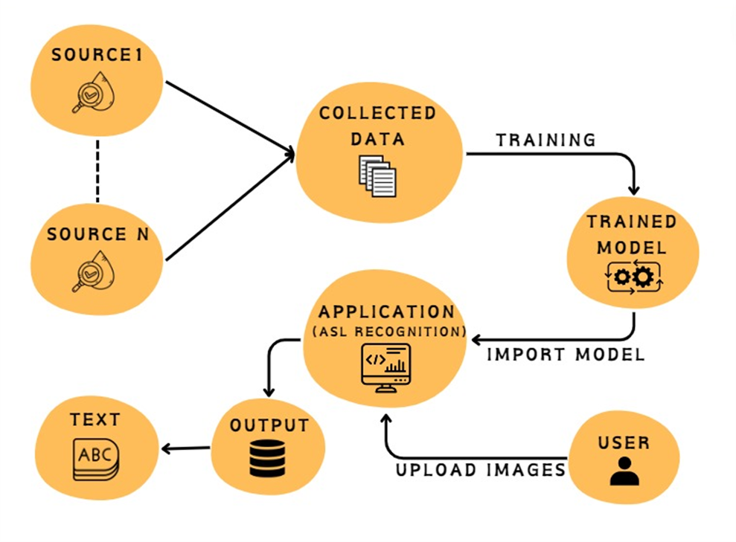

**User Stories**

Use the below template to list all the user stories for the product.

| **User Type** | **Functional**  **Requirement**  **(Epic)** | **User Story Number** | **User Story / Task** | **Acceptance criteria** | **Priority** | **Release** |
| --- | --- | --- | --- | --- | --- | --- |
| As a developer | Projet setup and infrastructure | USN-1 | Set up the development environment with the required tools and frameworks to start the ASL project . | Successfully configured with all necessary tools and frameworks. | High | Sprint-1 |
| As a developer | Data collection | USN-2 | Gather a diverse and large dataset of images containing all the different classes of alphabets(A, B, C, D, ….., Z), space, nothing, delete. | Gathered a diverse dataset of images (alphabets). | High | Sprint-1 |
| As a developer | Data Preprocessing | USN-3 | Preprocess the collected images by resizing and normalizing. Split the data into training and testing sets. | Preprocessed the dataset. | High | Sprint-2 |
| As a developer | Model Development | USN - 4 | Explore different deep learning architectures (CNN) to select the most suitable one for our ASL project. | Explore different DL models. | High | Sprint-2 |
| As a customer | Training | USN-5 | As a customer, I want a well trained model and very accurate predictions for the images I upload. Task: Implement data augmentation techniques to improve model’s accuracy. | Test the model after training to check accuracy. | Medium | Sprint - 2 |
| As a developer | Integrate the ASL recognition system into applications and services. | USN - 6 | As a developer, I want the ASL recognition system to offer an API or web browser for easy accessibility. | Develop a website using HTML, CSS, JS. | Medium | Sprint - 3 |
| Customer | Develop a web-based user interface for the ASL recognition system that provides users with a simple way to interact with the system. | USN - 7 | As a customer, I want to access the ASL recognition system through a user-friendly web interface, so I can easily interact with the system without the need to install additional software | Users can access the ASL recognition system through a web browser. | High | Sprint - 3 |